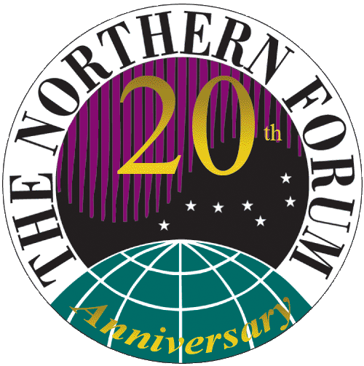

The Northern Forum X General Assembly

BOARD OF GOVERNORS

PYEONG-CHANG DECLARATION

Pyeong-Chang, Gangwon Province, Republic of Korea
3 June 2011

A. MISSION

It is the Mission of The Northern Forum:

To improve the quality of life of Northern peoples by providing Northern regional leaders a means to share their knowledge and experience in addressing common challenges; and
To support sustainable development and the implementation of cooperative socio-economic initiatives among Northern regions and through international fora.

B. BACKGROUND

The Tenth General Assembly of the Northern Forum and celebration of the 20th Anniversary of the organization was conducted in Pyeongchang, Gangwon Province, Republic of Korea, the proposed site of the 2018 Winter Olympics.

A Quorum of the members of the Board of Governors was present at the General Assembly, along with numerous guests, business partners, advisors, and observers. The members of the Board of Governors reviewed past initiatives and achievements; discussed current challenges for northern regions; considered issues of global concern; and developed a focused strategy for the coming two years activities.

Recognizing the continued role of regional governments in the global discussion around sustainable economic development, environment, and society and culture;

Reconfirming the commitment of the Northern Forum to promote constructive cooperation among northern regions;

Recognizing northern communities continue to be affected by unique and severe effects from climate change.

Underscoring the need to continue and expand research, monitoring and data collection supporting both scientific and traditional knowledge.

Recognizing the important role of the private business sector, chambers of commerce and business associations in the North.

Reconfirming the importance of the Northern Forum’s observer status at the Arctic Council, relations with other multilateral organizations, such as the nrg4SD and FOGAR, and international organizations including the United Nations and components of UNDP, UNFCCC, UNEP, UNESCO, and WHO as avenues to address regional concerns.

Noting that given changes in International relations, the global economy and growing concern about climate change and the environment, the Northern Forum membership reviewed the organization’s mission and overall goals and objectives and prepared an updated and refreshed Strategic Plan.

Past Major Accomplishments and Looking to the Future

In the Northern Forum’s Environment Program, the Board of Governors

Congratulate the Khanty-Mansiysk region with the success of the Youth EcoForum held in their region in June 2010, and Congratulate the staff at the NF Secretariat, in partnership with the University of Alaska, Anchorage, and the Chugach National Forest on the success of the Youth EcoForum (YEF) held in Anchorage, Alaska, May 1-8, 2011. With a rapidly growing concern for climate change and the impacts on our fragile northern environment, the 2011 Youth EcoForum focused attention on the multiple use management of the forest ecosystem and the impacts from climate change.

Welcome the Declaration prepared at the YEF in Anchorage, Alaska and recognize the contribution of youth in the global efforts to address climate change, and Acknowledge the YEF enhances youth awareness and understanding of the natural environment and note with appreciation the Yukon Government’s offer to host the next Youth EcoForum in Whitehorse, August 8-12, 2012.

Recognize the success of the Northern Forum’s Brown Bear Working Group workshop in Primorsky region, Russia in 2010 and the ongoing collaboration in genetics research, and Announce the Northern Forum’s 8th workshop of the Brown Bear Working group, August 2011, in Orsa Gronklitt, Sweden, that will bring together its members to discuss management and genetics, training and cooperation. And, recognize the value of working with local knowledge holders.

Congratulate the Sakha Republic and the Northern Forum Academy on the success of the Climate Change Conference held in June, 2010, and the resultant partnership with UNDP on an energy efficiency project in Sakha.

Acknowledge the continued cooperation between Northern Zoos and Task the participating regions to publish a management manual and photo album of Northern Zoos.

Recognize the importance of Arctic Council's on-going projects with regard to climate change and continue to support the Arctic Council's Working Groups as necessary, to ensure a voice for the regions in the work of the Council.

Support continued efforts of mapping permafrost and multiyear permafrost, and exchanging solutions to fight its degradation as a way of supporting regions in climate change adaptation and
Announce a Northern Forum’s workshop on adaptation to permafrost degradation to be held on the occasion of the General Assembly of nrg4SD to be held in Québec City August 29 – 31, 2011.

Announce the International Sea Duck Conference in Seward, Alaska, south of Anchorage, September 12-16, 2011, and Support continued assistance to the U.S. Fish & Wildlife in the logistics and organization of the conference.
In the Northern Forum’s Society and Culture Program

Welcome with appreciation the release of the Northern Forum Children’s 20th Anniversary Calendar produced under the leadership of Co-Chairs Yukon and Nunavut.

Acknowledge the importance of providing opportunities for youth projects, cultural and sports activities, and the 22nd Arctic Winter Games to take place in Whitehorse, Yukon on March 4-10, 2012; and supports with appreciation the efforts of the Sakha Republic in hosting the 5th International Children of Asia Games to take place in Yakutsk, 4-16 July, 2012.

Recognizing the high rates of suicide in the North and the urgent need to act to build healthy communities, encourage member regions to work cooperatively toward suicide prevention and associated substance abuse prevention in the North.

Continue to support the partnership between the Northern Forum and the Arctic Council focused on Infectious Disease Monitoring in Russia, and Recommend the inclusion of other regions in the North in these efforts.

Continue to advance telemedicine as an economically effective method in delivering health services to remote locations in the Arctic and decide to continue the asynchronous medical consultation project “AMS DoctorNet”.

In the Northern Forum’s Sustainable Economic Development Program

Recognizing air transport is often the only transportation mode in remote Arctic and northern regions, continue the Northern Aviation project aimed at training, researching air routes and identifying best models for Northern airports.

Recognize the importance of identifying best practices in sustainable development, and acknowledging the region-wide initiatives of sustainable development underway, including Quebec’s Plan Nord, encourage regions to develop cooperative efforts to address rural community sustainability.

Recognizing the critical importance of advancement of healthy communities and healthy northern economies, Commit to expanding partnerships, cooperation and exchange of technologies to address growing concerns of sustainable rural communities, and announce the Northern Forum workshop on the topic of rural sustainable development September 26-30, 2011 in Khanty-Mansiysk, Russia.

Recognizing the Arctic Council’s first, legally binding instrument focused on cooperation in Aeronautical and Maritime Search and Rescue in the Arctic; and Commit to continued partnership with the Arctic Council in forthcoming efforts toward search and rescue in the Arctic.

In the Northern Forum’s Operational Management

Note the significant improvement in the financial sustainability of the organization,

Recognize that the increased income requires clear and transparent financial management responsibilities and Adopt to conduct a financial audit at least biennially.

Acknowledge the need to develop sustainability within the organization through supporting internships to train youth in Northern Forum management activities and Commit to the development of a succession plan or transition plan for changes in Secretariat management.

THE BOARD OF GOVERNORS

EXPRESSED their sincere appreciation to Gangwon Province, Republic of Korea, for hosting the Northern Forum Tenth General Assembly; acknowledged the outstanding ability of Gangwon Province to host international events in their region; and wished the Gangwon Province the best in their bid for the 2018 Winter Olympics.

EXPRESSED their sincere appreciation to the regions of Nunavut and the Yukon for their two years as Co-Chairs of the Northern Forum, and acknowledge their focused efforts in developing financial sustainability in the organization and close coordination with the Secretariat.

